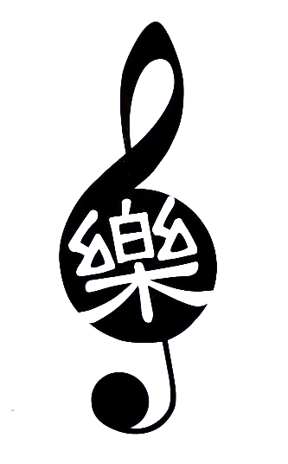
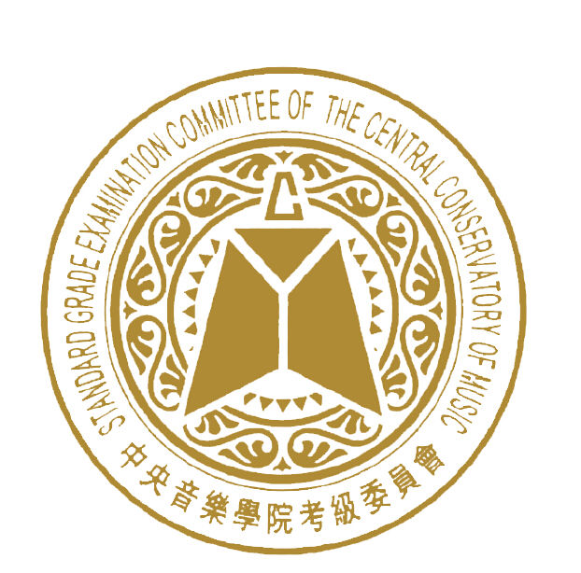

School of Chinese Music & Arts
         
民樂分級考試報名表 Graded Examinations Application form
*姓名Name:
*郵箱Email:
*地址Address:
*電話Contact number:
*出生日期Date of Birth:

Teacher  老師姓名 | Instrument  考級樂器 | Grade  級別 | Total Fees  收費 | Early-bird優惠价 | Late Fee遲報名 | Translation 翻譯

Application will only be confirmed upon receipt of fees.
Bank details are: School of Chinese Music and Arts, BSB: 035-016 Acc no: 946298
Thank you.

Office use only: Fees received $ Date: Others:
Points to Note:
1. Registration starts from 1st March 2018 to 30th September 2018. Applicants must ensure all information furnished in the application form is correct. No changes to the candidates’ names are allowed after the examination.
2. All application forms must be submitted together with the payment of the examination fees.
Only cash or EFT (bank transfer) payments are accepted. Please put down examinee name in bank
reference. (School of Chinese Music and Arts, BSB: 035016 Acc no: 946298)
3. Candidates registering for the Diploma examination are required to attach a photocopy of your Grade 9 certificate for verification.
4. Please note that if the certificate is to be printed with the teacher’s name, do indicate it in the specific section of the application form. Otherwise, the certificate will be printed without the teacher’s name. Please ensure that teacher’s name is correctly provided. The Examination Board will not be held responsible for any wrong information provided.
5. Absence:
a) Withdrawal notice from candidates who cannot be present for the examination must be made in writing with a valid explanation, as soon as the candidate realises his/her absentism is unavoidable but no later than the scheduled date of the examination, to “School of Chinese Music & Arts Graded Examinations Office”
b) Absence due to illness or infectious diseases must be supported by a medical certificate. Other valid reasons will be assessed on a case-by-case basis.
If the examination administrator deems the candidate’s explanation to be adequate, 50% of the examination fee may be refunded.
6. The examination will be held between 30November 2018 to 1 December 2018. Admission slip will be issued to inform of candidate’s actual exam date/time around mid October.
7. The Examination Board reserves the rights to amend the rules and regulations without prior notification.

注意事项:
1. 报名日期：2017年 3月1日 至 9月30日。考生须确保报名表格上所填写的资料准确无误. 表格一旦呈交, 所有个人资料不得更改。
2. 考试费与报名表格须一并呈上,不得延误。所有费用须以現金或銀行轉帳 至 School of Chinese Music & Arts (School of Chinese Music and Arts, BSB: 035-016 Acc no: 946298)
3. 演奏级考生必须附上九级文凭复印件以供确认。九级文凭是由中央音乐学院联颁的．
4. 若证书要印上老师的名字, 请在表格指定的栏目内填写。要不然, 证书将不会印上老师的名字。请确保所填写的资料准确无误，任何疏忽与遗漏，自行负责。
5. 考生若无法出席考试：
a. 须呈上缺席书面通知, 说明缺席原因, 在考试日期之前呈交 School of Chinese Music & Arts。
b. 若因生病不能参加考试, 须呈上缺席书面通知和病假单。
主考单位将酌情处理，凡符合上述两种情况者, 可考虑退还一半的考试费。
6. 考试订于2017 年11月 30日 至 12月1日期间举行，主考单位届将在十月中寄发考试入场证通知考生的考试时间表。
7. 如有必要，考级委员会有权修改考试规则。

